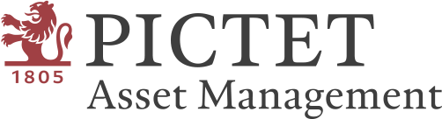

Investing in the Future University Competition 2023
by Pictet Asset Management

Proposal Cover Sheet

Requirement: The proposal must be written in English and must not exceed 1,500 words (excluding the reference section); use a 12-point Arial font with 1 line spacing.
Due on: 12nn (HKT/SGT), 13 November 2023 (Monday)
Submission Instructions:
- Please ensure that you provide the accurate information in below and attach this cover sheet to your proposal.
- Upload the proposal in word format using the designated link provided in the email sent to team leaders.
- Please name the proposal file using the format: Pictet - Team Name - Team Leader’s first and last name. (Example: Pictet – Team Sustainability – Marco Leung). Kindly ensure that you receive an acknowledgement email confirming your submission.
- Submissions that fail to comply with the requirements will be disqualified without further notice.
Should you have any concerns or require further assistance, feel free to reach out to us at
PictetInvestingInTheFuture@ruderfinn.com.

Submission date:
Team name (same as the one used during registration):
Team leader’s contact email (same as the one used during registration):
University name:
Region of university:
Word count (excluding reference section):

Our team hereby declares that this proposal represents original work and does not infringe upon any intellectual property rights of any third party. Our proposal is the result of diligent research conducted independently, using official information published by the selected company and other reputable public information sources. We agree and acknowledge that Pictet Asset Management's decisions regarding all aspects of the Competition as full and final, including but not limited to rule interpretations, eligibility, disqualifications, and award allocations.

Section 1: Company & Sector Overview

Section 2: Product and/or Service Description

Section 3: Assessment of Growth Potential

Section 4: References

[End of Proposal]

